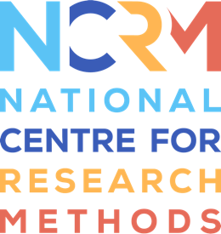
Fundamentals of Inclusive Research

Transcript Video 4 ‘recognition’
Full video, see: https://www.ncrm.ac.uk/resources/online/all/?id=20841

In research, we understand the value of participants' time and information. But how can we express recognition for their efforts effectively?
Factors such as personal preferences and the level of commitment required can influence how participants prefer to be acknowledged. Across hundreds of interviews, people have told us that one of the biggest reasons they take part in research is to help other people.
However, despite their altruistic motivations, participants may sometimes question the impact of their individual contributions. Communication at critical junctures like the beginning of the research journey can help participants realise that they're more than just numbers and that we truly value them taking the time for our research.
When communicating with participants—whether through personal interactions, invitations, or thank-you notes— think about wording that emphasises the significance of their involvement. add depth by explaining how or why they've had an impact in the context of your research and the questions you're trying to answer.
Another key way to show ongoing recognition is by promptly addressing any queries and being open to feedback. This fosters an environment where participants feel valued and heard, which not only motivates their initial involvement but also encourages ongoing participation. This approach can be particularly effective in longer-term studies, where maintaining participant engagement is vital.
Additionally, involving participants in decisions about how they'd like to be kept informed can further enhance their sense of involvement. Whether it's updates on research progress, summaries of data, key findings, or the impact of the research, providing choices ensures participants feel connected every step of the way.
It's important to acknowledge that there's no one-size-fits-all approach to recognition. Working with representatives of the target group can help identify meaningful incentives, which may include financial rewards, skill-building opportunities, acknowledgements, or access to something of interest in that group Be flexible where you can.
For example, a high street or food voucher that can be used at several places and which can be sent by post or online. By implementing these strategies, we can show people that their individual contributions are recognised.

National Centre for Research Methods (NCRM)
Social Sciences
Murray Building (Bldg 58)
University of Southampton
Southampton SO17 1BJ
United Kingdom
Web www.ncrm.ac.uk
Email info@ncrm.ac.uk
Tel +44 23 8059 4539
Twitter @NCRMUK

